Second
# Source: AI Source: Provided by: [Data Path: Persons Table -> ID Column: 1, Name_En Column: Motasem Essam] -> From: [ChatGPT] on [7/17/2026]
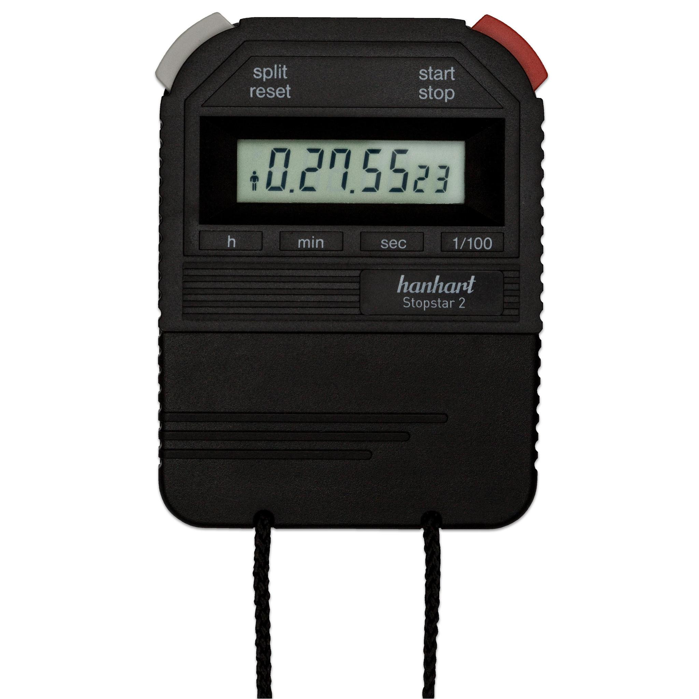
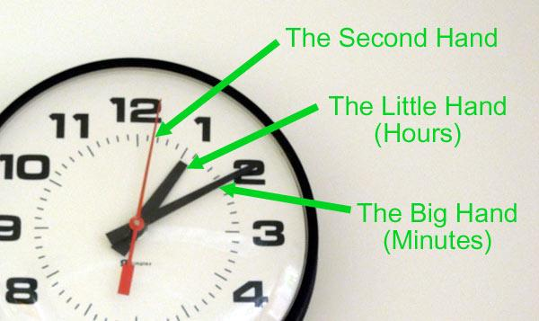
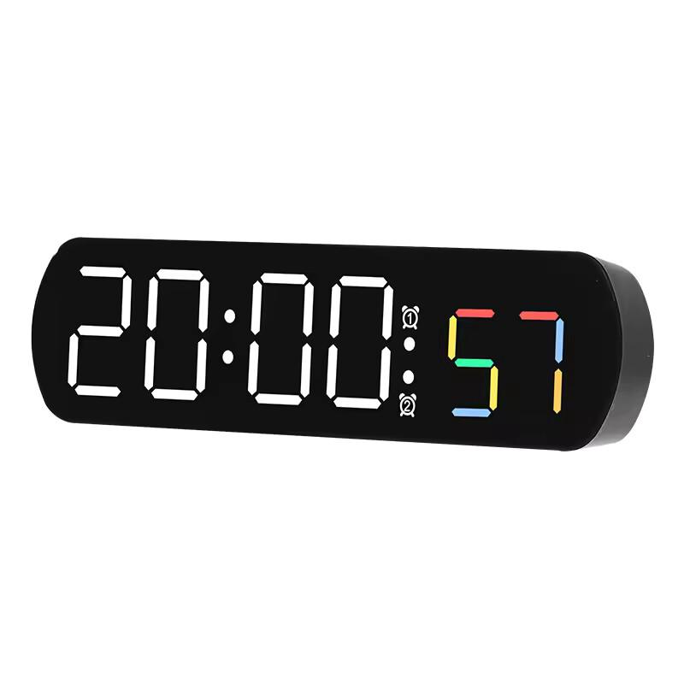
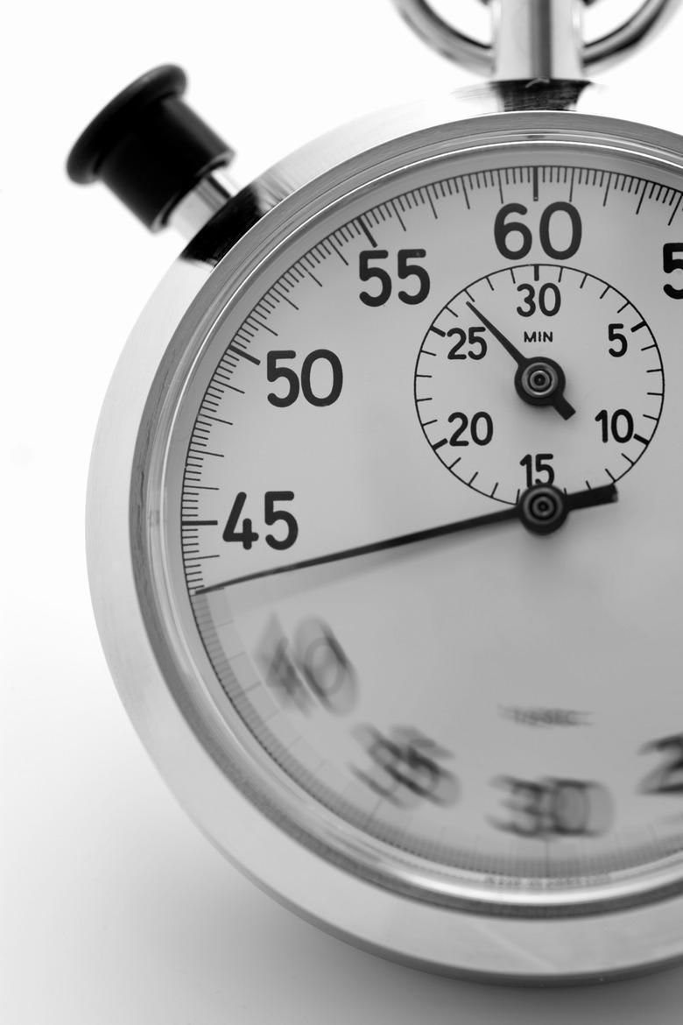
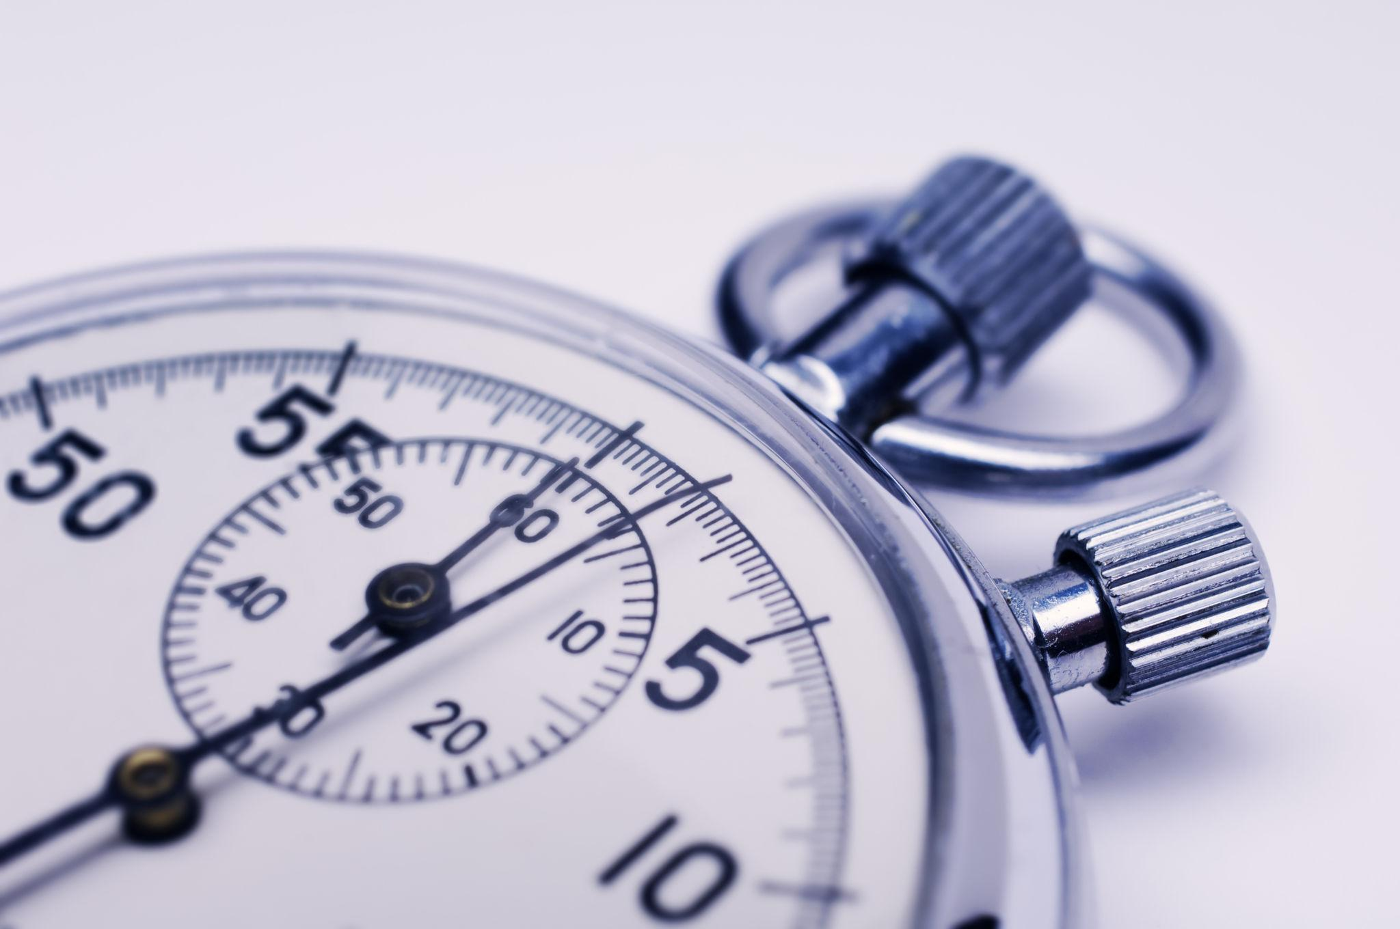
A Second is the base unit of time in the International System of Units (SI). It is used to measure very short time intervals and serves as the foundation for all larger units of time, including minutes, hours, days, and years.
The second is one of the most precisely defined measurement units in science and is essential in physics, engineering, astronomy, navigation, telecommunications, and everyday life.

Definition
# Source: AI Source: Provided by: [Data Path: Persons Table -> ID Column: 1, Name_En Column: Motasem Essam] -> From: [ChatGPT] on [7/17/2026]
A Second is the SI base unit of time, equal to one-sixtieth (1/60) of a minute.

SI Definition
# Source: AI Source: Provided by: [Data Path: Persons Table -> ID Column: 1, Name_En Column: Motasem Essam] -> From: [ChatGPT] on [7/17/2026]
Since 1967, the second has been defined using the properties of the cesium-133 atom.
The official SI definition is:
One second is the duration of 9,192,631,770 periods of the radiation corresponding to the transition between two hyperfine energy levels of the ground state of the cesium-133 atom.
This definition allows extremely precise and consistent time measurement worldwide.

Relationship to Other Time Units
# Source: AI Source: Provided by: [Data Path: Persons Table -> ID Column: 1, Name_En Column: Motasem Essam] -> From: [ChatGPT] on [7/17/2026]
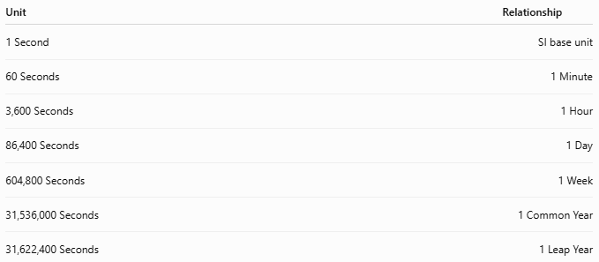
Unit | Relationship
1 Second | SI base unit
60 Seconds | 1 Minute
3,600 Seconds | 1 Hour
86,400 Seconds | 1 Day
604,800 Seconds | 1 Week
31,536,000 Seconds | 1 Common Year
31,622,400 Seconds | 1 Leap Year

Abbreviation
# Source: AI Source: Provided by: [Data Path: Persons Table -> ID Column: 1, Name_En Column: Motasem Essam] -> From: [ChatGPT] on [7/17/2026]
The standard SI symbol is:
- s
Examples:
- 5 s
- 30 s
- 120 s

Measuring Seconds
# Source: AI Source: Provided by: [Data Path: Persons Table -> ID Column: 1, Name_En Column: Motasem Essam] -> From: [ChatGPT] on [7/17/2026]
Seconds are measured using:
- Analog clocks
- Digital clocks
- Watches
- Stopwatches
- Timers
- Atomic clocks
- Computer system clocks

Second Hand on an Analog Clock
# Source: AI Source: Provided by: [Data Path: Persons Table -> ID Column: 1, Name_En Column: Motasem Essam] -> From: [ChatGPT] on [7/17/2026]
On a traditional analog clock:
- The second hand is usually the longest and thinnest hand.
- It moves:
  - One tick every second
  - One complete revolution every 60 seconds

Applications
# Source: AI Source: Provided by: [Data Path: Persons Table -> ID Column: 1, Name_En Column: Motasem Essam] -> From: [ChatGPT] on [7/17/2026]
Seconds are used in:
- Scientific experiments
- Sports timing
- Physics
- Engineering
- Computer processing
- Telecommunications
- GPS navigation
- Medical monitoring
- Everyday timing

Conversion Examples
# Source: AI Source: Provided by: [Data Path: Persons Table -> ID Column: 1, Name_En Column: Motasem Essam] -> From: [ChatGPT] on [7/17/2026]
Seconds to Minutes
Divide by 60.
Example:
$$180\text{ s}=180÷60=3\text{ min}$$

Minutes to Seconds
Multiply by 60.
Example:
$$4\text{ min}=4×60=240\text{ s}$$

Seconds to Hours
Divide by 3,600.
Example:
$$7,200\text{ s}=7,200÷3,600=2\text{ h}$$

Hours to Seconds
Multiply by 3,600.
Example:
$$2\text{ h}=2×3,600=7,200\text{ s}$$

Subdivisions of a Second
# Source: AI Source: Provided by: [Data Path: Persons Table -> ID Column: 1, Name_En Column: Motasem Essam] -> From: [ChatGPT] on [7/17/2026]
Scientists often measure much smaller intervals of time.
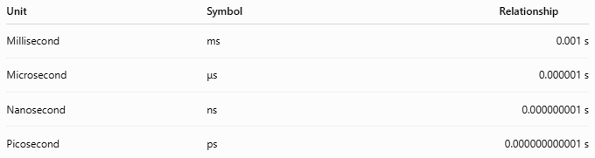
Unit | Symbol | Relationship
Millisecond | ms | 0.001 s
Microsecond | μs | 0.000001 s
Nanosecond | ns | 0.000000001 s
Picosecond | ps | 0.000000000001 s

Common Examples
# Source: AI Source: Provided by: [Data Path: Persons Table -> ID Column: 1, Name_En Column: Motasem Essam] -> From: [ChatGPT] on [7/17/2026]
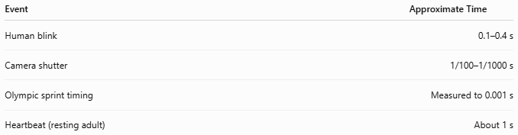
Event | Approximate Time
Human blink | 0.1–0.4 s
Camera shutter | 1/100–1/1000 s
Olympic sprint timing | Measured to 0.001 s
Heartbeat (resting adult) | About 1 s

Advantages
# Source: AI Source: Provided by: [Data Path: Persons Table -> ID Column: 1, Name_En Column: Motasem Essam] -> From: [ChatGPT] on [7/17/2026]
Using seconds allows:
- Extremely precise measurements.
- International standardization.
- Accurate scientific calculations.
- High-precision timing in technology and sports.

Common Mistakes
# Source: AI Source: Provided by: [Data Path: Persons Table -> ID Column: 1, Name_En Column: Motasem Essam] -> From: [ChatGPT] on [7/17/2026]
- Confusing seconds (s) with minutes (min).
- Using sec instead of the SI symbol s in scientific writing (although "sec" is common in informal contexts).
- Assuming all clocks measure seconds with the same precision (only atomic clocks achieve the highest accuracy).

Interesting Facts
# Source: AI Source: Provided by: [Data Path: Persons Table -> ID Column: 1, Name_En Column: Motasem Essam] -> From: [ChatGPT] on [7/17/2026]
- The second is one of the seven SI base units.
- Modern atomic clocks can lose or gain less than one second over millions of years.
- The Global Positioning System (GPS) relies on extremely accurate measurements of seconds to determine positions on Earth.

Key Points
# Source: AI Source: Provided by: [Data Path: Persons Table -> ID Column: 1, Name_En Column: Motasem Essam] -> From: [ChatGPT] on [7/17/2026]
- A Second is the SI base unit of time.
- 60 seconds = 1 minute.
- It is officially defined using the cesium-133 atom.
- Seconds are used in science, engineering, sports, computing, navigation, and everyday life.
- Smaller units include:
  - Milliseconds
  - Microseconds
  - Nanoseconds

Conclusion
# Source: AI Source: Provided by: [Data Path: Persons Table -> ID Column: 1, Name_En Column: Motasem Essam] -> From: [ChatGPT] on [7/17/2026]
A Second is the fundamental unit of time measurement in the International System of Units (SI). Defined by the precise oscillations of the cesium-133 atom, it provides the foundation for all larger time units and enables highly accurate measurements across science, technology, engineering, navigation, and daily life. Its precision and universal standardization make the second one of the most important measurement units in the modern world.

